High Roller SuperSpin Choreography

Art list:
Asset | Details | Estimated time
Pot (3 skins) | Red, Blue, yellow

Animation list (total 47 hr):
Asset | Details | Estimated time
Pot (3 skins) | setting | 8
 | Idle (6 levels) | 8
 | Hit (6 levels) | 8
 | Level up (4 levels) | 8
 | Trigger (5 levels) | 8
Purple Star  **will use High Rollers’ Dream’s Green star’s Animations as a base, so this one won’t take long | setting | 1
 | idle | 2
 | srs | 2
 | win | 2

Pots (3skins)

Idle Animation
Symbol | 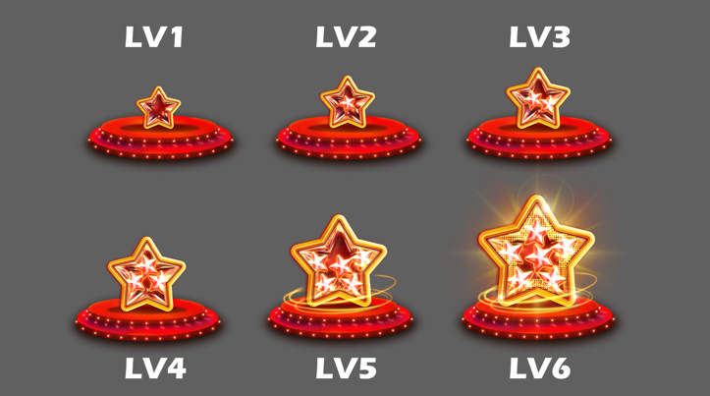
Looping | yes
Duration | 5 sec
Description | 6 levels  - Small stars inside the jar bouncing/jumping and spinning

Hit
Symbol | 
Looping | yes
Duration | 0.5 sec
Description | - Lv 1  - Lv2  - Lv3  - Lv4  - Lv 5  - Glass Star Pots get hit and bounce back  - Tiny star effect explodes from the center  - Star-shaped fx grow from the center

Level Up
Symbol | 
Looping | no
Duration | 1 sec
Description | Lv 1-2  Lv 2-3  Lv 3-4  Lv 4-5  - Glass Star Pot  - The design looks like a glass star.  - From Level 1–5, the glass star collects smaller stars inside and grows larger.

Trigger Animation
Symbol | 
Looping | no
Duration | 1 sec
Description | Trigger (5 levels)  - Lv 1-6  - Lv 2-6  - Lv 3-6  - Lv 4-6  - Lv 5-6  - When triggered, the star explodes and releases the small stars.

Purple star (3 skin)

Srs Animation
Symbol | 
Looping | yes
Duration | 0.5 sec
Description | - srs should grow the star and reveal one of 3 features (3 animations needed) *** We decided to use 3 skins for each feature instead of using animations

Win
Symbol | 
Looping | yes
Duration | 1 sec
Description | - win is looping the revealed feature name

Idle
Symbol | 
Looping | yes
Duration | 5 sec
Description | - Subtle movements  - idle (no text)***

